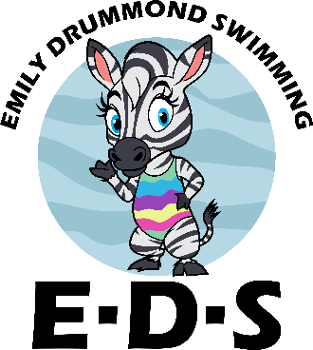**Get to know you form (Student)**

Name: Nickname:

Favourite colour: Favourite TV show:

Favourite animal: Favourite food:

Favourite thing about swimming?

Least favourite thing about swimming?:

What do you want to be when you grow up?:



What should Miss Emily know about you?:



What do you want Miss Emily to teach you?: