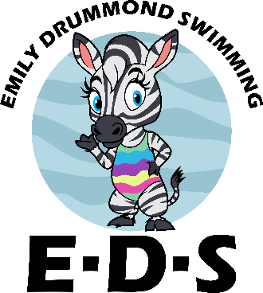**Get to know you form (Caregiver)**

Name: Relationship to child:

What are your goals for your child?:



Has your child done lessons before?:





What did you like/dislike about the lesson?:





What would you like me to do differently?:





Your child's past experience in the water?: (Positive and negative)





How does your child learn best? (i.e. Clear instructions , play/imagination etc)



What are your child's interests?:





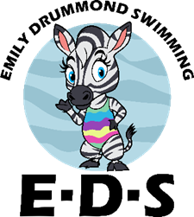

How did you hear about E.D.S?:

*online word of mouth local advertisement past student other*

Why did you chose E.D.S?:



Is there anything I should know about your child?



Other comment: